GURU Profile :
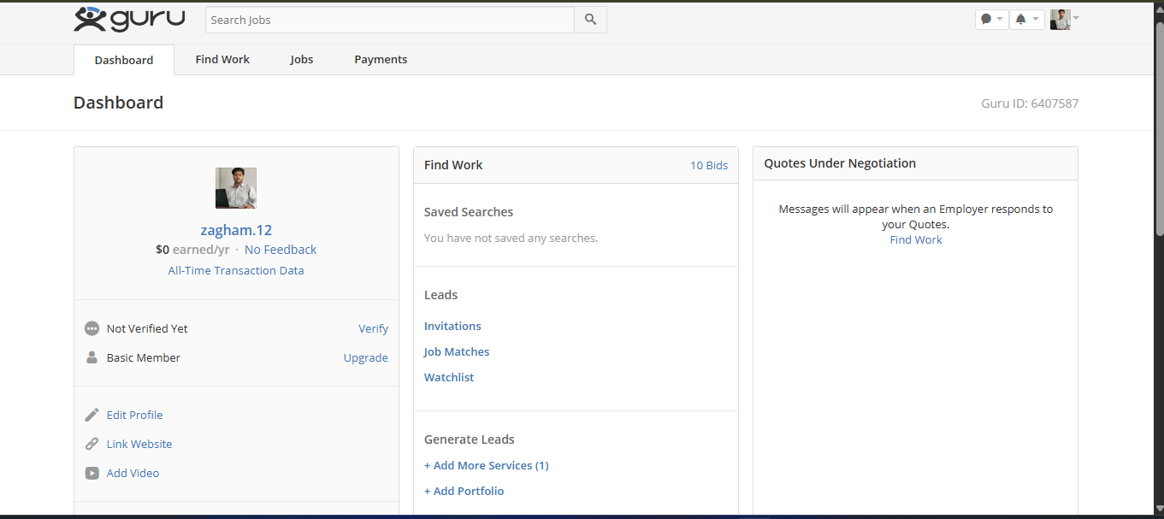
Facebook Profile :
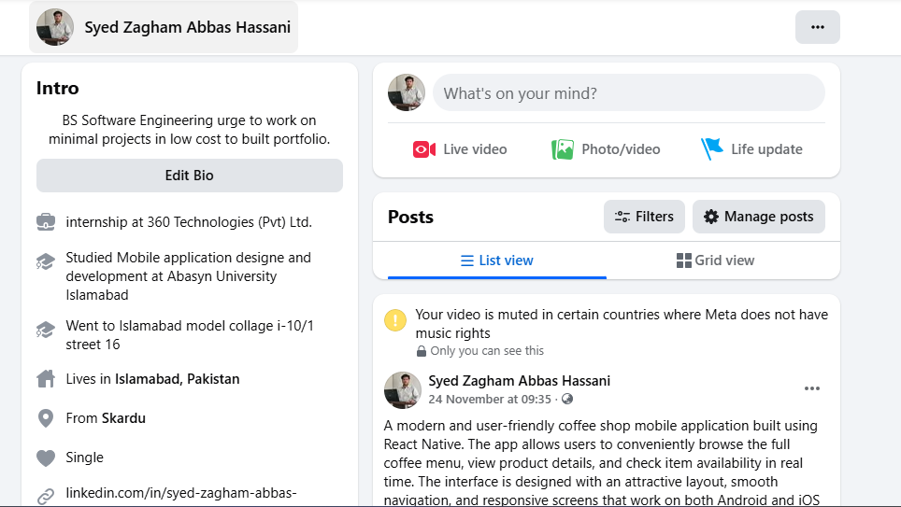
Freelancer Profile:
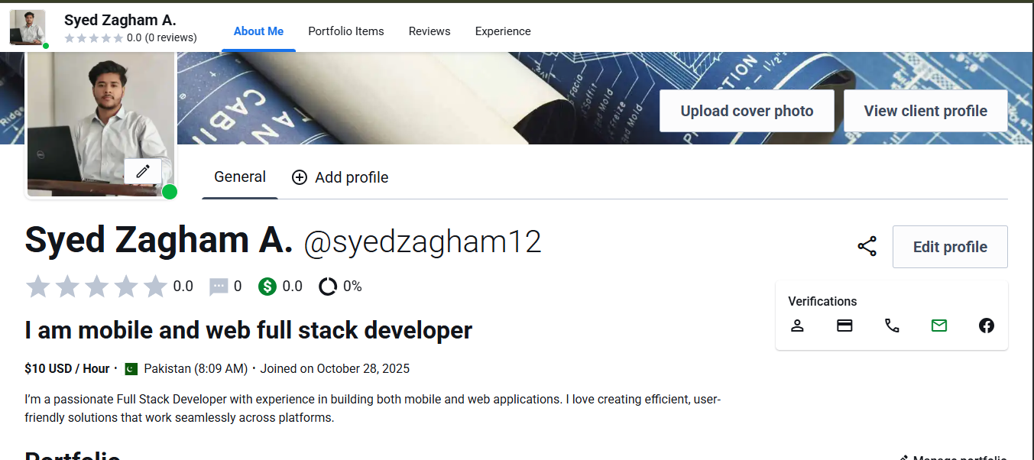

Problem: Too Much Competition & Low Visibility
On freelancing platforms and Facebook job posts, thousands of developers apply for the same project. New or less-reviewed developers often get ignored because clients mostly choose profiles with high ratings or long work history. As a result, even good proposals don’t get a response. This makes it difficult to stand out and reduces the chances of getting selected.

